Consultation Form

**Please answer the following questions to enable you to be given a safe and effective treatment. You may be asked to obtain approval and advice from your Doctor or any healthcare professional involved in your welfare before starting massage treatment.**

**Any information given below is treated in the strictest confidence and no additional information will be sought without your prior permission.**

Conducting subjective and objective assessment

|  |  |
| --- | --- |
| **Centre name:** |  |
| **Learner name:** |  |
| **Date:** |  |

|  |  |  |
| --- | --- | --- |
| **Client name:** |  | |
| **Address:** |  | |
| **Profession:** |  | |
| **Telephone number:** | Day: |  |
| Evening: |  |

|  |  |  |  |  |  |  |
| --- | --- | --- | --- | --- | --- | --- |
| Personal details: | | | | | | |
| Age group: | Under 20 ☐ | 20 – 30 ☐ | 30 – 40 ☐ | 40 – 50 ☐ | 50 – 60 ☐ | 60+ ☐ |
| Lifestyle: | Active ☐ | | | Sedentary ☐ | | |
| Last visit to the doctor: |  | | | | | |
| GP address: |  | | | | | |
| Number of children:  *(If applicable)* |  | | | | | |
| Date of last period:  *(If applicable)* |  | | | | | |

|  |
| --- |
| The client’s reason for the sports massage treatment and what the she or he would like to achieve |
|  |

|  |  |  |  |  |  |
| --- | --- | --- | --- | --- | --- |
| Contra-indications requiring medical permission – *in circumstances where medical permission cannot be obtained clients must give their informed consent in writing prior to treatment* *(Select if/where appropriate):* | | | | | |
| Pregnancy | ☒ | Epilepsy | ☐ | Cancer | ☐ |
| Cardiovascular conditions (thrombosis, phlebitis, hypertension, hypotension, heart conditions) | ☐ | Recent operations | ☐ | Postural deformities | ☐ |
| Haemophilia | ☐ | Diabetes | ☐ | Spastic conditions | ☐ |
| Any condition already being treated by a GP or another health professional, e.g., Physiotherapist, Osteopath, Chiropractor, Coach | ☐ | Any dysfunction of the nervous system (e.g., Muscular sclerosis, Parkinson’s disease, Motor neurone disease) | ☐ | Kidney infections | ☐ |
| Medical oedema | ☐ | Bell’s palsy | ☐ | Whiplash | ☐ |
| Osteoporosis | ☐ | Trapped/Pinched nerve (e.g., sciatica) | ☐ | Slipped disc | ☐ |
| Arthritis | ☐ | Inflamed nerve | ☐ | Undiagnosed pain | ☐ |
| When taking prescribed medication | ☐ | Acute rheumatism | ☐ | Nervous/psychotic conditions | ☐ |

|  |  |  |  |  |  |
| --- | --- | --- | --- | --- | --- |
| Contra-indications that restrict treatment *(Select if/where appropriate):* | | | | | |
| Fever | ☐ | Varicose veins | ☐ | Sunburn | ☐ |
| Contagious or infectious diseases | ☐ | Pregnancy (abdomen) | ☐ | Hormonal implants | ☐ |
| Under the influence of recreational drugs or alcohol | ☐ | Cuts | ☐ | Abdomen (first few days of menstruation depending how the client feels) | ☐ |
| Diarrhoea and vomiting | ☐ | Bruises | ☐ | Haematoma | ☐ |
| Skin diseases | ☐ | Varicose veins | ☐ | Hernia | ☐ |
| Undiagnosed lumps and bumps | ☐ | Abrasions | ☐ | Recent fractures (minimum 3 months) | ☐ |
| Localised swelling | ☐ | Scar tissue (2 years for major operation and 6 months for a small scar) | ☐ | Cervical spondylitis | ☐ |
| Gastric ulcers | ☐ | After a heavy meal | ☐ | Inflammation | ☐ |

|  |  |
| --- | --- |
| Written permission required by(either of which should be attached to the consultation form):– | |
| GP/specialist ☐ | Informed consent ☐ |

|  |
| --- |
| Pre-existing conditions/disease processes (therapeutic and remedial): |
|  |

|  |  |  |  |  |  |  |  |  |  |  |  |
| --- | --- | --- | --- | --- | --- | --- | --- | --- | --- | --- | --- |
| Personal information *(Select if/where appropriate):* | | | | | | | | | | | |
| Muscular/skeletal problems: | Back | ☐ | Aches/pain | | ☐ | Stiff joints | | | ☐ | Headaches | ☐ |
| Digestive problems: | Constipation | ☐ | Bloating | | ☐ | Liver/gall bladder | | | ☐ | Stomach | ☐ |
| Circulation: | Heart | ☐ | Blood pressure | | ☐ | Fluid retention | | | ☐ | Tired legs | ☐ |
| Varicose veins | ☐ | Cellulite | | ☐ | Kidney problems | | | ☐ | Cold hands and feet | ☐ |
| Gynaecological: | Irregular periods | ☐ | P.M.T | | ☐ | Menopause | | | ☐ | H.R.T | ☐ |
| Pill | ☐ | Coil | | ☐ | Other | | | | | ☐ |
| Nervous system: | Migraine | ☐ | Tension | | ☐ | Stress | | | ☐ | Depression | ☐ |
| Immune system: | Prone to infections | | ☐ | Sore throats | | | ☐ | Colds | | | ☐ |
| Sinuses | | | | ☐ | Chest | | | | | ☐ |
| Current medical condition/  Treatment | Pain nature onset | ☐ | Duration | | ☐ | Daily pain pattern: | | |  | | |
| Aggravates sitting | ☐ | Standing | | ☐ | Walking | | | ☐ | Running | ☐ |

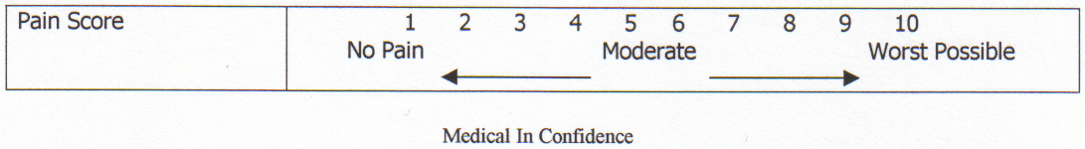

|  |  |  |  |  |  |  |  |  |  |  |  |  |  |  |  |  |  |  |  |  |  |  |
| --- | --- | --- | --- | --- | --- | --- | --- | --- | --- | --- | --- | --- | --- | --- | --- | --- | --- | --- | --- | --- | --- | --- |
| History of present condition (select if/where appropriate): | | | | | | | | | | | | | | | | | | | | | | |
| Recurring injury | Yes | | | | | | | | | | ☐ | No | | | | | | | | | | ☐ |
| What treatment was undertaken? |  | | | | | | | | | | | | | | | | | | | | | |
| How long did the injury take to heal? |  | | | | | | | | | | | | | | | | | | | | | |
| Did you have any investigations? | Yes | | | ☐ | No | | | | | | ☐ | If yes, which ones: | | | | | | |  | | | |
| Regular  antibiotic/  medication taken? | Yes | | | ☐ | No | | | | | | ☐ | If yes, which ones: | | | | | | |  | | | |
| Herbal remedies taken? | Yes | | | ☐ | No | | | | | | ☐ | If yes, which ones: | | | | | | |  | | | |
| Ability to relax: | Good | | | | | ☐ | | Moderate | | | | | | | ☐ | | Poor | | | | | ☐ |
| Sleep patterns: | Good | | | ☐ | Poor | | | | | | ☐ | Average no. of hours | | | | | | | | |  | |
| Do you see natural daylight in your workplace? | Yes | | | | | | | | | | ☐ | No | | | | | | | | | | ☐ |
| Do you work at a computer? | Yes | | | ☐ | No | | | | | | ☐ | If yes, how many hours | | | | | | | | |  | |
| Do you eat regular meals? | Yes | | | | | | | | | | ☐ | No | | | | | | | | | | ☐ |
| Do you eat in a hurry? | Yes | | | | | | | | | | ☐ | No | | | | | | | | | | ☐ |
| Do you take any food/vitamin supplements? | Yes | | | ☐ | No | | | | | | ☐ | If so, which ones? | | | | | | |  | | | |
| How many portions of each of these items does your diet contain per day? | Fresh fruit: | | |  | Fresh vegetables: | | | | | |  | Protein and source: | | | | | | |  | | | |
| Dairy produce: | | |  | Sweet things: | | | | | |  | Added salt: | | | | | | |  | Added sugar: | |  |
| How many units of these drinks do you consume per day? | Tea: | | |  | Coffee: | | | | | |  | Fruit juice: | | | | | | |  | Water: | |  |
| Soft drinks: | | |  | Others: | | | | | | | | | | | | | | | | |  |
| Do you suffer from food allergies? | Yes | | | | | | | | | | ☐ | No | | | | | | | | | | ☐ |
| Bingeing? | Yes | | | | | | | | | | ☐ | No | | | | | | | | | | ☐ |
| Overeating? | Yes | | | | | | | | | | ☐ | No | | | | | | | | | | ☐ |
| Do you smoke? | Yes | | | | | | | ☐ | | No | | | | | | ☐ | | How many a day? | | | |  |
| Do you drink alcohol? | Yes | | | | | | | ☐ | | No | | | | | | ☐ | | How many units a day? | | | |  |
| Do you exercise? | None | | | ☐ | Occasional | | | | | | ☐ | Irregular | | | | | | | ☐ | Regular | | ☐ |
| Types: | | | |  | | | | | | | | | | | | | | | | | |
| What is your skin type? | Dry | ☐ | Oily | | | | ☐ | | Combination | | | | ☐ | Sensitive | | | | | | ☐ | Dehydrated | ☐ |
| Do you suffer/have you suffered from | Dermatitis | | | ☐ | Acne | | | | | | ☐ | Eczema | | | | | | | ☐ | Psoriasis | | ☐ |
| Allergies | | | ☐ | Hay Fever | | | | | | ☐ | Asthma | | | | | | | ☐ | Skin cancer | | ☐ |
| Stress level 1–10 (10 being the highest): | At work | | | | | | | | | | ☐ | At home | | | | | | | | | | ☐ |

|  |  |
| --- | --- |
| **Physical examination:** | |
| Observations: |  |
| Head: |  |
| Shoulders: |  |
| Back: |  |
| Pelvis: |  |
| Legs: |  |
| Feet: |  |
| Body alignment/ posture: |  |

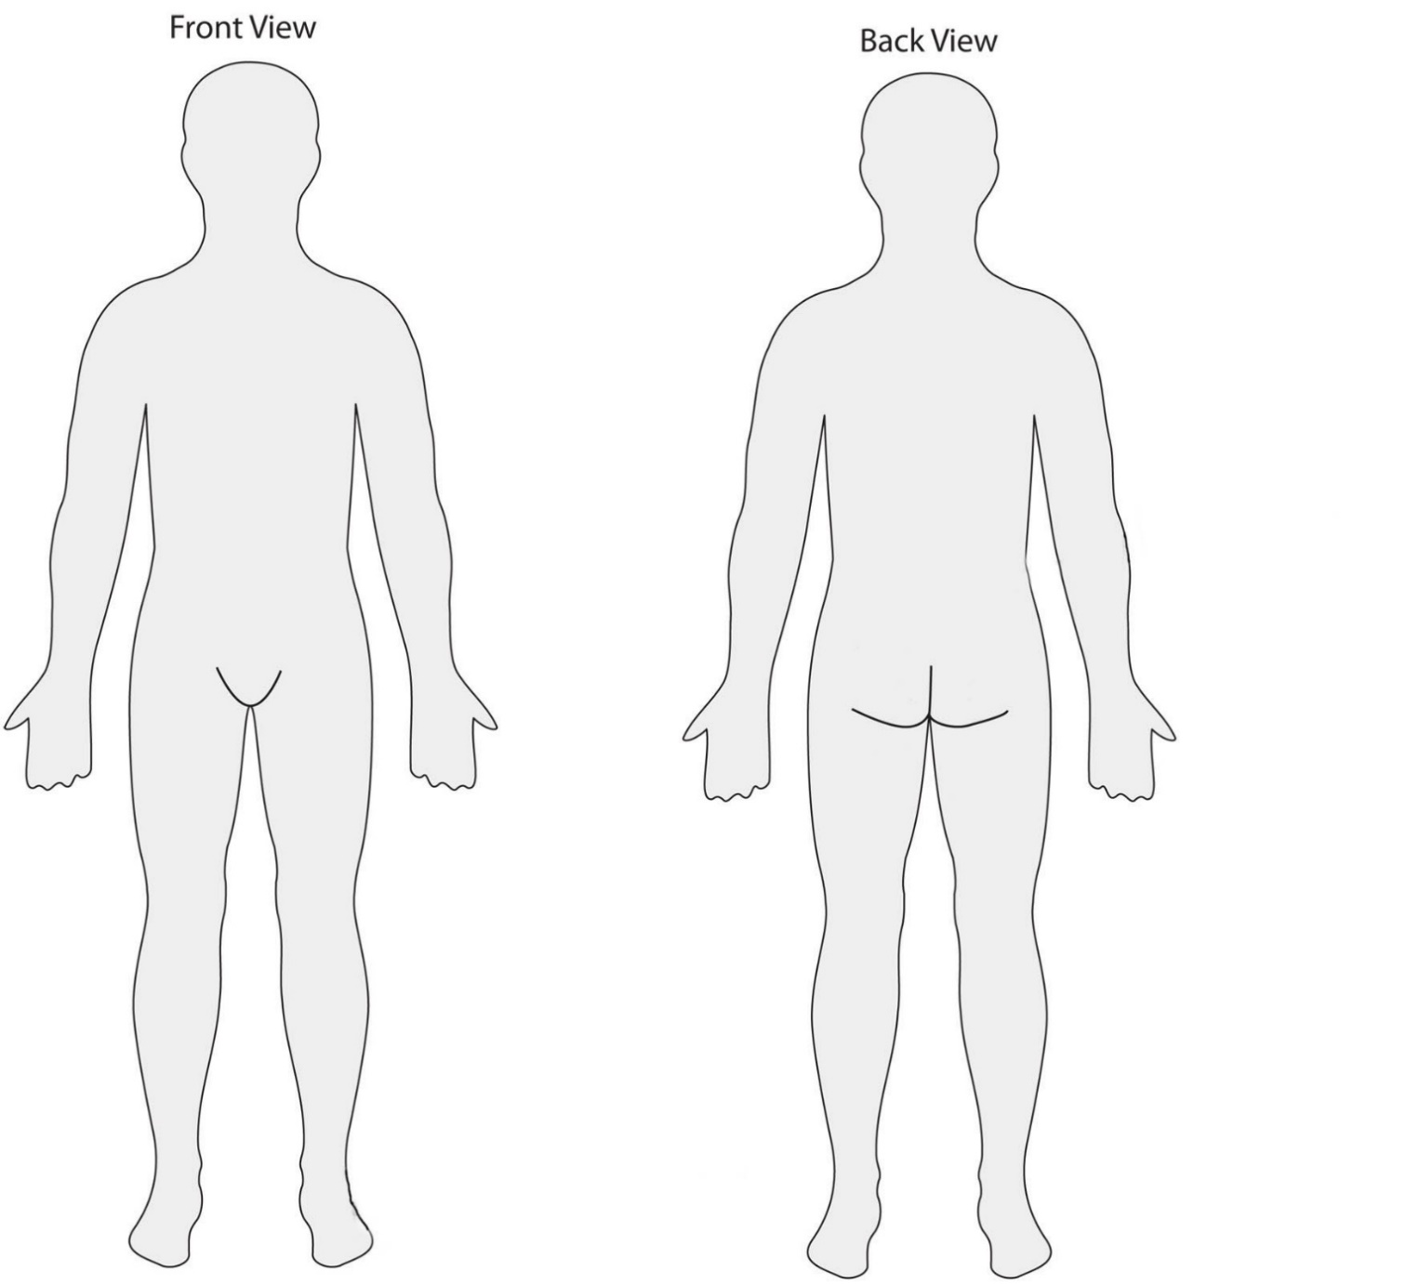

|  |
| --- |
| Palpations: |
|  |

|  |
| --- |
| Functional tests: |
|  |

|  |  |  |  |  |  |
| --- | --- | --- | --- | --- | --- |
| **Joint movement tested: to include spinal range and movement of the upper and lower limbs** | | | | | |
| Joint/active/ passive ROM Pre-treatment | Right | Left | MET | Right  Post-treatment | Left  Post-treatment |
|  |  |  |  |  |  |
|  |  |  |  |  |  |
|  |  |  |  |  |  |
|  |  |  |  |  |  |
|  |  |  |  |  |  |

|  |  |  |
| --- | --- | --- |
| Muscle tests – Isometric strength testing(resisted): | | |
| Muscle group | Right | Left |
|  |  |  |
|  |  |  |
|  |  |  |
|  |  |  |
|  |  |  |
| Muscle length tests |  |  |
|  |  |  |
| Muscle bulk |  |  |
|  |  |  |

|  |  |  |  |
| --- | --- | --- | --- |
| Special tests: | | | |
| Test | Right | Left | Comments |
|  |  |  |  |
|  |  |  |  |
|  |  |  |  |
|  |  |  |  |
|  |  |  |  |
|  |  |  |  |

|  |
| --- |
| Treatment plan and state rationale for chosen massage interventions: |
| **Hypothesis:**  **Treatment Plan:**  **Rationale:** |

**I** confirm that the above information I given is accurate to the best of my knowledge.

I will keep my therapist up to date with any changes to my physical health.

I know no reason why I should not receive treatment.

I understand that treatments undertaken by me at my own risk and that the therapist may not be able to cure my complaint.

I understand and agree to receive the treatment explained to me by the therapist.

**Learner signature**: _______________________________________________________________________________

**Client signature**: _________________________________________________________________________________

**Date**: _________________________________________________________________________________________